# **NGO Management**

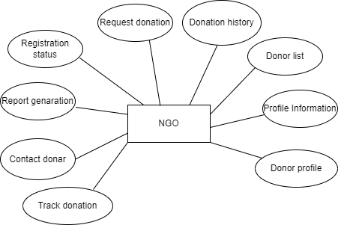

* **Registration status**: Indicates whether the NGO's registration is approved, pending, or rejected.
* **Request donation**: After approval NGO can request for donation post.
* **Donation history**: Maintains a record of all past donations received by the NGO.
* **Donar list**: NG can access a list of donors who have donated for the NGO.
* **Profile information**: Contains details about the NGO, such as name, address, and contact information. NGO can update or modify their profile.
* **Donor profile**: Holds information about each donor, including their name and contact details that NGO can visit.
* **Track donation:** NGO cantrack the status and progress of each donation request.
* **Contract donor:** NGO can contract a donor for donation request.
* **Report generation:** Allows the NGO to create reports summarizing donation activities.